Dragons

The Dragon in Europe
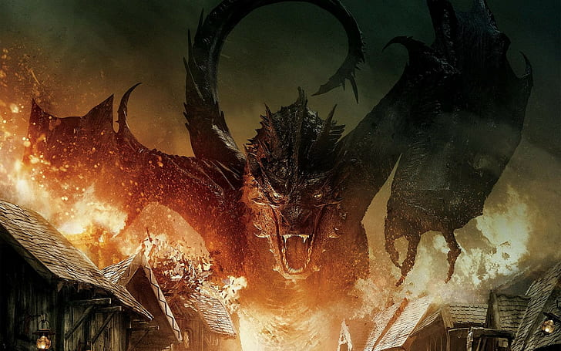
General
- Best known dragons in Europe and America
- Mighty Enemy and beast
- Often four legs, long snake neck, reptilian head, fire breath
- Represents biggest fear -> in Christianity the hell itself
- Often used in heraldic
Origin
- Caves
- Volcanoes
- Snakes

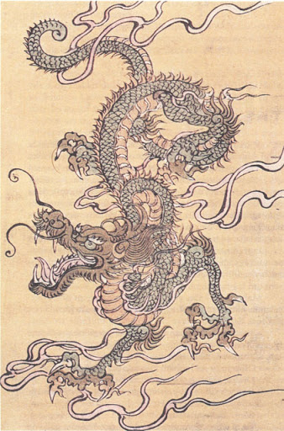
Lóng
General
- snakelike body, with reptilian legs, but without wings, often grinning face with beart
- Ancestor of mankind and lord of water
- Important in chinese culture
Origin
- Snake
- Illustriation of a Chinese scholar

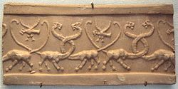
First Dragons
- First mention: 450 B. C. by Herodot -> Mixed dinosaur bones were held for dragon bones by mistake
- First illustration: 3500 B. C. in Uruk -> panther body, snake neck & head

Sources
https://www.sueddeutsche.de/wissen/frage-der-woche-woher-stammen-die-drachen-1.571873
https://www.youtube.com/watch?v=j4FIRN08wHc
https://de.wikipedia.org/wiki/Long_(Mythologie)
https://www.planet-wissen.de/kultur/fabelwesen/drachen/pwiederchinesischedrache100.html
https://www.smithsonianmag.com/science-nature/where-did-dragons-come-from-23969126/

Image sources
- https://www.wallpaperflare.com/the-hobbit-smaug-the-hobbit-the-desolation-of-smaug-movies-wallpaper-uymcd
- https://de.wikipedia.org/wiki/Drache_(Mythologie)#Vorderer_Orient
- https://www.pinterest.de/pin/332703491192887201/

